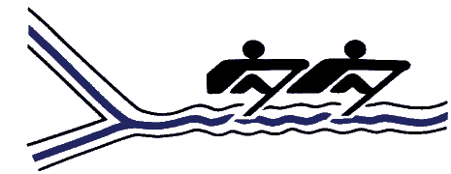
The Kingston Rowing Club
P.O. Box 1016, Kingston, Ontario, K7L 4X4
Tel: 613-542-4767 / Email: armitage@llynlea.com

2015 Summer Junior Rowing Program

(Please print clearly)

Name: ______________________________________________________________________________
Address: _____________________________City:_________________Postal Code: ____________________

Junior Participation Waiver:
I agree to abide by all Kingston Rowing Club rules, by-laws, safety regulations, and code of conduct. I agree and acknowledge that I undertake any activity including rowing, weight and fitness training entirely at my own risk, and that I am medically fit to undertake such activity. I acknowledge that I may be asked to undertake activities such as boat moving/loading/unloading, dock installation/removal and other activities that may require the ability to lift heavy objects., In consideration of my application as a participant in the KRC programs, I hereby release, waive, and forever discharge the Kingston Rowing Club and its coaches and volunteers of and from all claims in respect to injury, loss or damage to my person of property. I warrant that I am able to swim at least 100 meters, and am physically fit to participate in competitive rowing. I agree to my photograph being used for publicity and/or web site purposes. I acknowledge that a parent or designated adult is responsible for transportation to and chaperoning at regattas.
I have read and acknowledge that I understand the implications of these statements by submitting and signing this form.

Signature of Participant

Signature of Parent/Guardian (if the participant is under 18)

Date

